Unit 2 Assignment

Desmond Hughes

Purdue University Global

HU200: Arts and Humanities

Elliot Crozat

Part 1: The first architectural work I found is the Lane House, which was built in 1718. It is known to be the oldest house in North Carolina which is where I live. The house is a white house, that shows the foundation clearly, with a white screen door. The side of the house is cracked at the bottom below a window. The house’s roof is slated to a point in the middle, which kind of looks like the top half of a star, with a chimney and a porch that is grey and about 3 steps that lead to the porch, and in front of the house is a sidewalk and then a tree.

(Thomas, 2013)

The architectural concept I picked is Sky-Oriented Architecture, and it is represented by ‘Figure 6-14’ in the Textbook (Jacobus, 2022), which is the Sagrada Familia (Church of the Holy Family, interior), Barcelona. To me a Sky-Oriented Architecture concept is when the architectural catches the eye of someone by showing off the uniqueness of the structure at the top of the structure, with an intriguing and stylist design. This style is important because it makes the top of the structure stand out from others and adds a unique touch. For example, the structure Sagrada Familia (Church of the Holy Family) the high point of the structure catches your eye when you look at the building.

“Such architecture discloses a world by drawing our attention to the sky bounded by a horizon.”( Jacobus, 2022) I was right about catching the attention to a high point of the structure when it comes to Sky-Oriented Architecture. Reading the textbook more about the concept, the concept also uses the light to help catch people’s eye, while defying gravity.

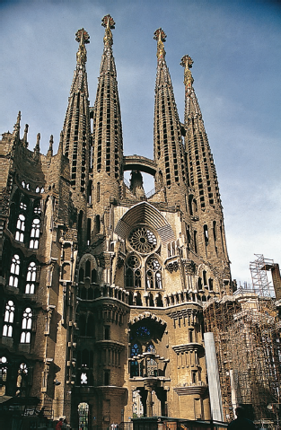( Jacobus, 2022)

Part 2: The structure I picked is the Newbold White House in Hertford, North Carolina, and is also one of the first architectural structures of North Carolina built in 1726. I picked this house because it has a very interesting look and caught my eye, being a completely brick rectangular, two-story house, with two chimneys on each side of the house and a red door, and red window outlines, and a small staircase leading to the front door that is also red, and grey shingles on the roof to compliment the bricks. It is also the oldest brick house in North Carolina.

(*Newbold-White House* n.d.)

The next architecture concept I will look at is ‘Integration of Light’ using ‘Figure 6-18’ from the textbook (Jacobus, 2022), which is Hagia Sophia (Church of the Holy Wisdom of God), in Istanbul. Integration of Light to me means using the light and its ability create a great experience, and also creative feeling to create a relaxing feeling to the inside of the structure. By looking at the picture given in the textbook for the interior of Hagia Sophia, it shows the lights being used to give the building a lively look and creates a calm feeling.

“Isadore and Anthemius were nonprofessional architects who used light materials to create a huge well-lighted interior” (Jacobus, 2022) I guess was similar to what the text stated . The light is used for orientation and security. The light opens up the environment of the structure, by using the windows in the structure, and opens the interior of the structure up.

References

Jacobus, L. (2022). Humanities through the Arts (11th ed.). McGraw-Hill Higher Education (US). <https://purdueuniversityglobal.vitalsource.com/books/9781264360215>

Anonymous (n.d.) *Newbold-White House*, *www.visitnc.com*. Available at: https://www.visitnc.com/listing/e2qZ/newbold-white-house (Accessed: April 18, 2023).

Thomas, R. (2013) *Discovery of the oldest dated house in North Carolina*, *Edenton Historical Commission*. Available at: https://ehcnc.org/decorative-arts/southern-architecture/discovery-of-the-oldest-dated-house-in-north-carolina/ (Accessed: April 18, 2023).